**SELNIUM AUTOMATION & DOCKER IMPLIMENTATION PROJECT**

Name : Harika Burna

Employee.ID : 201452

E-mail : Harika.Burna@amdocs.com

CONTENTS :

* Selenium
* Spring Boot Initializer
* Docker

INTRODUCTION

* **Selenium :**
* 🡪 Selenium is an open-source, automated testing tool used to test web applications across various browsers.
* 🡪 Selenium was originally developed by Jason Huggins in 2004
* 🡪 Selenium supports multiple Operating Systems and also multiple programming language.
* 🡪 Selenium web driver is most popular in Java and C#
* **Docker :**
* **🡪** Docker is a software platform that allows you to build, test, and deploy applications quickly.
* **🡪** Docker packages software into standardized units called containers that have everything the software needs to run including libraries, system tools, code, and runtime.

AUTOMATION USING SELENIUM TOOL

* A screenshot of a computer

  Description automatically generatedImporting Web Drivers and implementing simple google website

Searching for item in amazon website

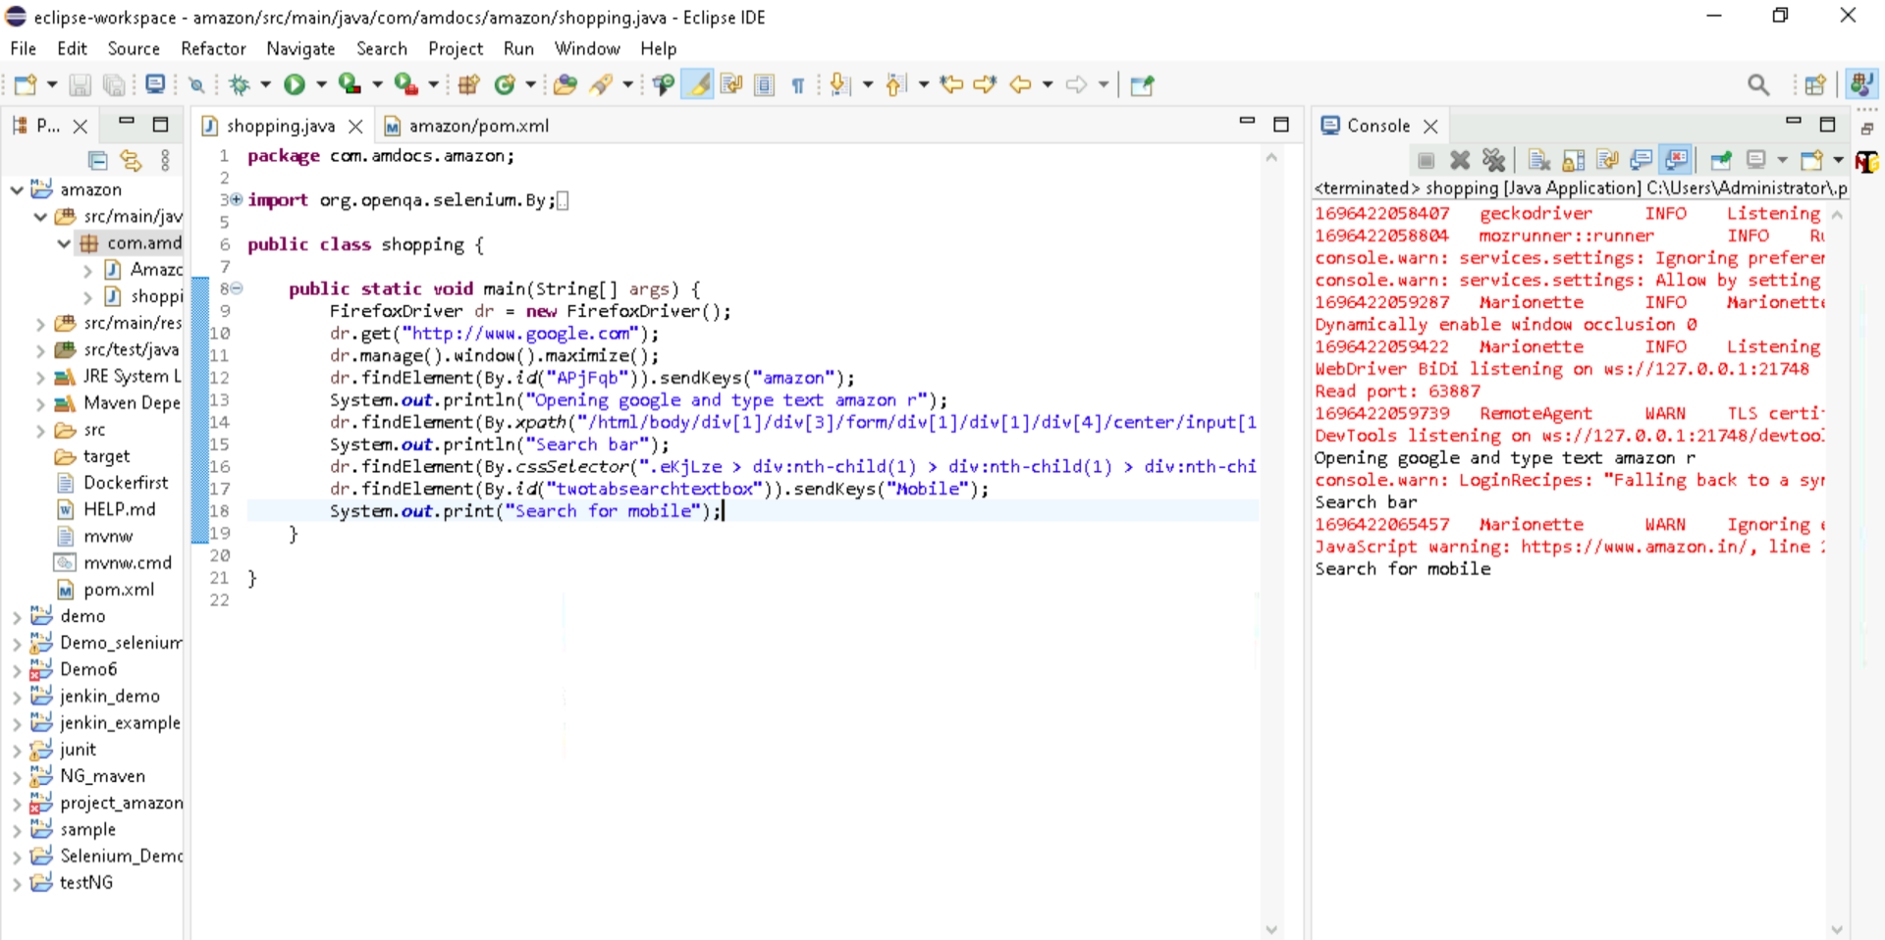

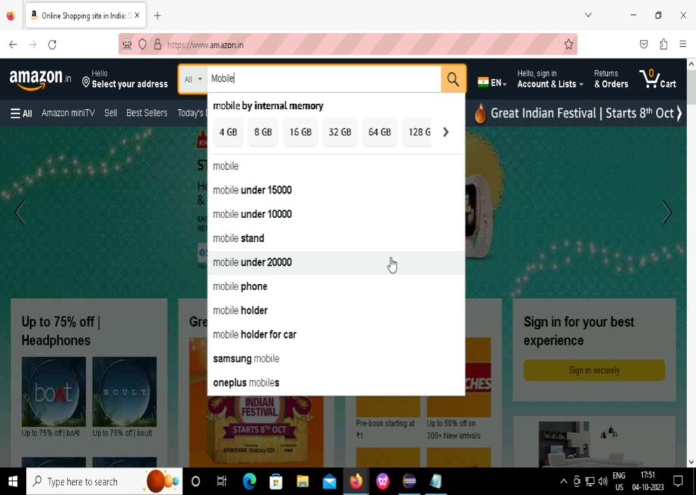

Adding filters for the sort the items

Output :

**S**electing a item from list

Output :

Adding the item to the cart

Output :

DOCKER  
  
Creation of a simple spring boot project for Dockerization

Docker Implementation

Creating JAR file

* A screenshot of a computer

  Description automatically generatedA screenshot of a computer

  Description automatically generatedProject 🡪Right click 🡪 Run as 🡪 Maven Install

Implementing docker commands for dockerization

Output :

